HomeAut demo

  - on STM32 Nucleo F401RE and STM32F4 Discovery

Author:
Vizi Gábor

Revision: r1
2016-12-22

Prologue

This document and project show „How to use an STM32F4 microcontroller”. This microcontroller family factored by STmicroelectronics, which is the one of the largest IC factory. I want to give a demo, which has a command handler, which process the command via UART, and you can set GPIO (General Purpose Input-Output) port.
This demo available on STM32F4 Discovery (STM32F407VG), and on STM32 Nucleo F401RE (STM32F401RE). These devkits (Development Kits) are the most famous and cheapest available devkits.

How to use this demo on your installed devkit?
- Prepare these:
  - Devkit
  - miniUSB cable
  - USB-UART converter
  - connection cable between USB-UART converter and devkit
  - Download and install a serial terminal, for example
    - FastenTerminal
    - ZOC
    - PuTTy
    - HyperTerminal
    - etc.
- Connect USB-UART converter to your devkit with cables
  - On devkit, use these pins:
    - PC6 (TX)
    - PC7 (RX)
    - GND
  - Do not forget the swap! (TX-RX)
- Connect miniUSB cable to your devkit and PC (for supply)
- Connect USB-UART converter to your PC
- Start your serial terminal
- Start serial receiving with this settings:
  - Baudrate: 9600
  - Type: 8N1
    - 8 bit / byte, No parity, 1 stop bit
- Reset devkit with reset button
  - Now, the devkit send welcome messages
- Type a command, and send it
  - The devkit will respond
  - For example, use the “help” command
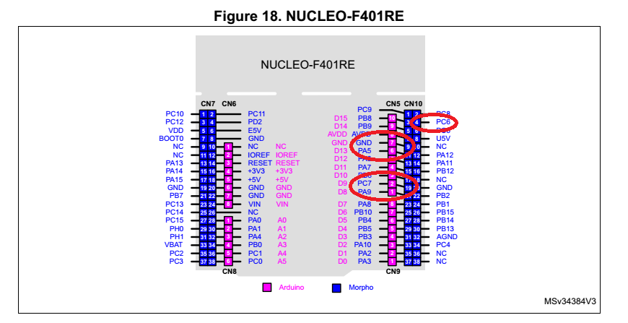
1. image - UART pin connections

What can I do with this demo?

In this demo available source code (project) and you can to something in this demo with commands.
Some important command:
- help
- help <command>
- ioinit
- ioin
- ioout
- adc
Check the attached commands details.
Open Projects\STM32F407DiscoHomeAut\DoxyDocs\html\index.html

How to install the demo, if you have a new devkit?

- Prepare these:
  - devkit
  - miniUSB cable
  - ST-link utility
- Connect the miniUSB cable to your devkit and the PC or notebook.
- You can download program:
  - Copy the binary to new mass storage drive (for example: G:\ drive)
  - or program with ST-link utility
  - or Debug (and download) with IDE
- Enjoy it!

Links

http://atollic.com/
https://www.emtec.com/zoc/

